RAWLINS INTERAGENCY DISPATCH CENTER

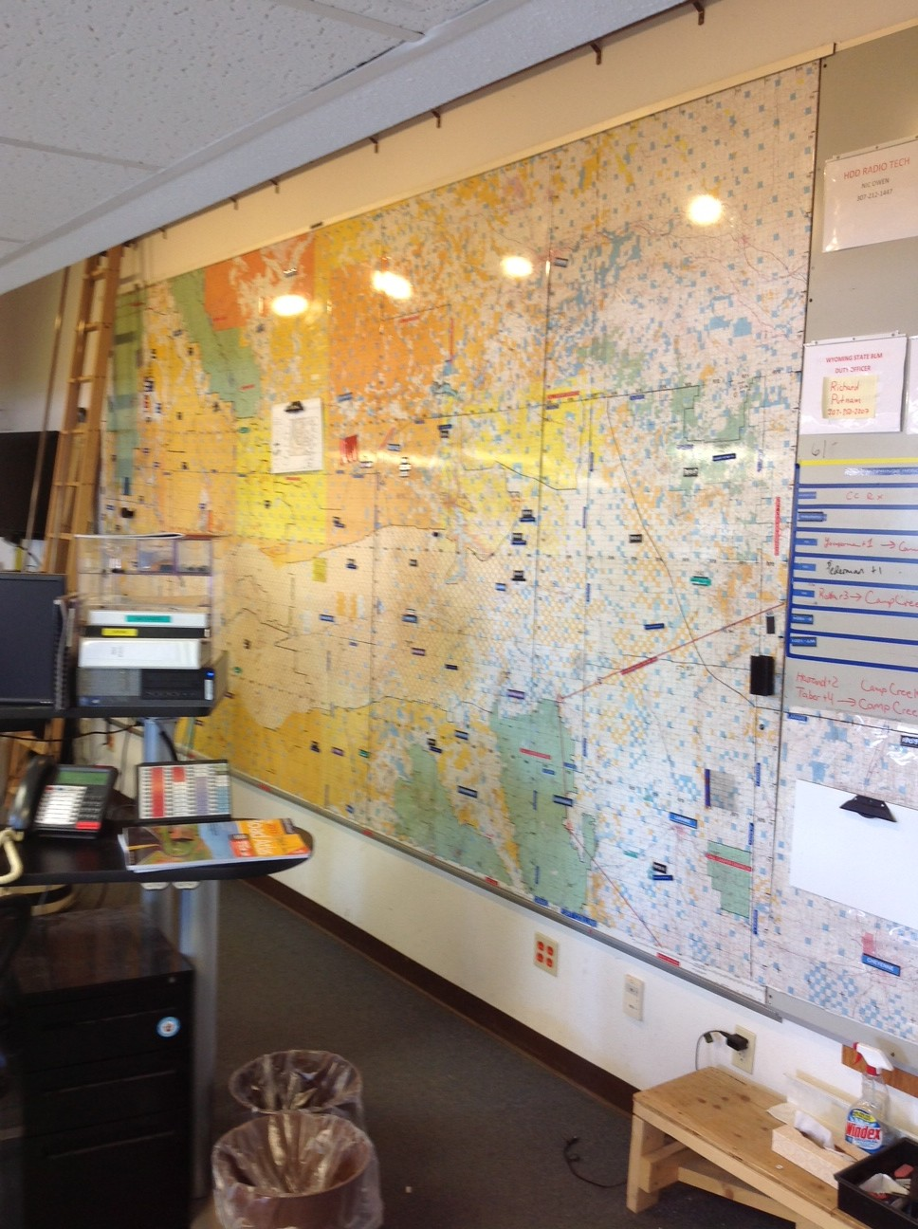

2013 ANNUAL REPORT
January 2, 2014

Prepared by Scott Russell, Center Manager
Introduction to the Center
Rawlins Interagency Dispatch Center is hosted by Bureau of Land Management’s High Desert District. The center is located in Rawlins, WY. Rawlins is a town of 9,700 people located off Interstate 80 in the middle part of the lower half of Wyoming. We provide services for seven counties, four BLM Field Offices, BLM Wyoming State Office, Wyoming State Forestry, the National Park Service, and the US Fish & Wildlife Service.

Our staff includes one Center Manager, one Assistant Center Manager, one career-seasonal Initial Attack Dispatcher, and one career-seasonal Logistics Dispatcher. During the summer months we hire one to three seasonal dispatchers. This year we had three seasonal dispatchers.

The dispatch zone covers approximately 21 million acres in the state of Wyoming. 48% of this land is owned by the Federal Government (approximately 10 million acres). A large percent of the High Desert District is checkerboard due to the Union Pacific Railroad that runs through Southern Wyoming. This type of land ownership is cause for a multiple agency response to incidents throughout the District.

Center Funding
Rawlins Dispatch Center is funded predominantly by the Bureau of Land Management through the High Desert District. This includes facility costs for the center as well as labor costs associated with staffing the center. All personnel are BLM funded employees, assigned to the High Desert District’s Fire Management program. Labors costs associated with having a fully staffed center are approximately $266,695 (based upon 2013 GS wages).

In 2013, the Center Manager position remained vacant resulting in some salary savings. In 2014, the center expects to fill both manager positions, but will eliminate one seasonal dispatcher position resulting in a reduction of annual labor costs by 7%. While the BLM High Desert District directly funds the majority of the expenses of RWC, other agencies do contribute intermittently. In 2013, $1,500 was received to support Rawlins Dispatch. Carbon County, Albany County and Albany Fire District #1 each provided $500 to fund the center. In previous years (2010, 2011 & 2012), Wyoming State Forestry has provided funds totally $11,500. Due to reduced budgets and funding cuts RWC actively solicits funds from the agencies it continues to support.

Overview of the 2013 Year
The 2013 year started out with the Assistant Center Manager (Russell) and one career seasonal (Scribner) employee working. Efforts to fill the Center Manager position were unsuccessful in the fall of 2012 and the effort was renewed in early 2013. To provide adequate coverage of RWC, the newly hired CS dispatcher (Scribner, hired in November of 2012) worked through the winter while the Assistant Center Manager attended training and meetings in line with the Center Manager’s obligations. January’s activities included flight following of Resource aircraft as well as winter pile burning.

Pile burning continued in February and aviation operations switched from Resource flights to MAFF’s (Modular Aerial Fire Fighting) training with the C-130’s based in Cheyenne Wyoming. Due to a family emergency, Russell spent much of February out of state and Scribner managed the day to day operations of RWC. March and April continued a pattern of wet and cold weather with several days of snow and intermittent fire activity. The first wildfire of the season was reported (Big Hill, ¼ acre on BLM) in March and the biggest fire of the year occurred at the end of April; the Seven Seas, a human caused fire north of Cokeville Wyoming burned 200 acres of sagebrush. The Career Seasonal Logistics Dispatcher (Mitchell) also returned to work in April and RWC sent out the first of several dispatchers in support of incident activity in other zones.
In May, the Assistant Center Manager detailed into the Center Manager position. An outreach was conducted to backfill the ACM position, but was met with limited interest. May 20th was the start date for the seasonal firefighting resources, including a returning Pathways (formerly STEP program) student and a seasonal logistics dispatcher. Fire activity was minimal for the month of May with only six incidents reported. June saw the arrival of our second seasonal dispatcher and an increase in fire activity. Between June 13th and June 30th, nineteen fires occurred, making June the busiest month for initial attack.

July had fifteen fires with three lightning caused fires occurring on July 4th. All fires stayed relatively small, with the largest being less than 12 acres. RWC filled seventeen resource orders in support of incidents across the country during the month of July to include BLM Wyoming State Office overhead, High Desert District personnel and equipment, County overhead and equipment, RWC dispatchers and the opening of the Rawlins SEAT base to support incidents in other zones. BLM Wyoming State Office provided leadership support to RWC in late July with Foster spending 30 days providing leadership and guidance to the program, allowing Russell the opportunity to do an out of state assignment starting in early August. August was the second busiest month with eighteen fires and eighty total incidents in the month. The Slate fire, a 23 acre lightning caused fire, was the biggest of the month. One seasonal dispatcher departed in mid-August for a permanent position elsewhere, further reducing the RWC staff which remained under-staffed throughout the year.

September continued with reduced fire activity in the zone. A total of 8 fires were reported for the month with twenty-two total incidents for the month. Major flooding occurred in northern Colorado and, in addition to team mobilizations, RWC supported the all-hazard incidents with dispatchers and other overhead. The Career Seasonal dispatcher Scribner went into furlough status and the Pathways student resigned to accept a position. October started with a federal government shut down with almost everyone being furloughed except Russell for 16 days. No fires occurred in October and a total of 4 incidents were reported for the month. RWC continued to support the flooding incidents in Colorado and Career Seasonal dispatcher Mitchell was furloughed on the 18th of the month.

Seasonal dispatcher (Watson) finished his employment in early November leaving the center staffed solely by Russell. Fuels reduction activity continued in November with a hazardous fuel cutting project continuing until the 15th of the month. Two prescribed fires occurred in November for a total of 333 acres. The Center Manager position was re-advertised in November and in December the position was formally offered to the Assistant Center Manager (Russell). December brought widespread snow showers and winter weather with continued pile burning and the close out of the calendar year.

Fire Activity
The 2013 fire season was a stark contrast to the 2012 season. The first reported fire in the zone was on BLM managed lands just south of Wamsutter Wyoming. At ¼ acre it was quickly controlled by Wamsutter resources and BLM fire units responded to extinguish the fire. A second fire (Lamb Chop) occurred in Lincoln County and this fire proceeded to smolder through broken terrain and animal carcasses for much of the summer, never becoming a treat to spread, yet not declared out until the end of October.
The 2013 fire season consisted of 79 wildfires, 54.4% originated on Private/State land:

For a total of 573.87 acres burned, 72% of which were Private/County land:

The 39 County fires reported occurred in six of the seven counties within RWC’s zone. The only county reporting no fire activity in 2013 was Laramie County.

While Sweetwater County reported the most fires (40%), it was Lincoln County with the most acres burned (53%).

Notable Fires:
Big Hill was reported on 03/10/2013 just south of Wamsutter Wyoming. Caused by an oil pad flare up, it was the first fire of 2013 in the zone.
Seven Seas was reported on 04/27/2013 in Lincoln County. This human caused fire was on private but threatened both BLM lands and structures. At 200 acres it became the single largest fire in 2013.
Sand Butte was reported on 08/08/2013. The lightning caused fire grew to 77.5 acres before being contained. It was the second largest fire in the zone in 2013 and started on private land in Sweetwater County.
Superior Fire was reported on 06/21/2013. At 59.1 acres, this human caused wildfire is the third largest fire to occur in the zone.
These three fires (Seven Seas, Sand Butte & Superior) account for 60% of all acres burned in 2013. The fourth largest fire was less than ½ the size of the Superior fire. A complete breakdown of all fires and their acres is available in Appendix A of this report.
2013 FIRE STATISTICS
UNIT | HUMAN |  | LIGHTNING |  | PRESCRIBED
 | FIRES | ACRES | FIRES | ACRES | FIRES | ACRES
High Desert District | 12 | 70.45 | 24 | 84.07 | 8 | 708
HDD Counties | 28 | 325.17 | 11 | 93.65 | 0 | 0
Mortensen Lake NWR | 0 | 0 | 0 | 0 | 1 | 1
Fossil Butte | 0 | 0 | 0 | 0 | 0 | 0
Cokeville | 0 | 0 | 0 | 0 | 0 | 0
Wyoming State Forestry | 4 | .55 | 0 | 0 | 0 | 0
TOTALS | 44 | 396.62 | 35 | 177.72 | 9 | 709
5 YEAR AVERAGE | 56 | 4912.58 | 46 | 8018.86 | N/A | N/A
TOTAL NUMBER OF FIRES: 70 TOTAL NUMBER OF ACRES: 556.89
Not all counties may have reported every fire; County numbers may vary from other reports
5 YEAR AVERAGES

FIREFIGHTER SAFETY & INJURY REPORT

While the number of fires and the acres involved were down in 2013, the number of firefighter injuries was up. Through the BLM’s Safety Management Information System (SMIS) firefighters are identified as participating in one of four activities when they were injured: Wildland Fire, Prescribed Fire/RX (to include mechanical fuel treatment), Physical Training (PT) and Non-Fire Related. Since 2010, and regardless of the wildland fire workload, the number of firefighters injured annually has remained steady at five (5). However in 2013, six firefighter injuries were reported. In 2013, fifty percent of the firefighter injuries were related to PT with two injuries from Prescribed Fire and one injury while on a Wildland Fire (Dehydration/Altitude Sickness).

Though data was only available covering the previous three years, it is clear from the chart above that Physical Training (with 8 injuries over four years) is the number one cause of firefighter injuries reported in the High Desert District. These numbers represent all firefighter injuries reported on incidents within the zone or by firefighters working for the High Desert District on assignments outside of the zone. Not available are records of non-HDD firefighters (BLM Wyoming, NPS, FWS, County Cooperators) injured while working incidents outside of the RWC zone.

CAD INCIDENTS BY TYPE

INCIDENT TYPE | NUMBER
Aircraft | 21
Haz Mat | 2
Medical Aid | 1
Miscellaneous | 13
Prescribed Fire | 11
Resource Order | 76
SAR | 0
Smoke Check | 56
Structure Fire | 1
Traffic Collision | 0
Vehicle Fire | 4
Wildfire | 70
Total | 255

2013 RESOURCE MANAGEMENT
Resources Ordered
Aircraft:
TYPE OF AIRCRAFT | ORDERED (2012)
I.A. Smokejumper Loads | 0 (3)
Type 1 or 2 Airtanker | 0 (25)
SEAT’s | 3 (56)
Aerial supervision Module | 0 (7)
Air Tactical | 6 (29)
Lead Plane | 0 (7)
Type 1 Helicopter | 0 (23)
Type 2 Helicopter | 0 (8)
Type 3 Helicopter | 1 (16)
IR Flight | 0 (21)
Temporary Flight Restriction (TFR) | 0 (5)
Air to Air Frequency | 0 (5)
Air to Ground Frequency | 0 (4)
Total: 10 (213)

Crews:
TYPE OF CREW | ORDERED
Type 1 | 0 (4)
Type 1 or Type 2 IA | 0 (17)
Type 2 or 2-IA | 0 (19)
Crew Misc. | 0 (2)
Total: 0 (42)

Equipment:
Dozers | 0 (6)
Engines | 10 (81)
Caterer’s | 0 (2)
Water Trucks/ Tenders | 0 (10)
Miscellaneous Equipment | 0 (9)
Trailers (Commo, Helicopter etc.) | 0 (3)
Transportation (trucks, ATV’s etc.) | 0 (18)
Mobile Shower Units | 0 (1)
Total: 10 (126)

Resources Sent Out

Given the nature of a moderately slow fire season in southern Wyoming, Rawlins Dispatch was able to fill multiple resource orders for events outside of our zone. RWC filled 126 Overhead orders and 53 Equipment orders for the following agencies:

These numbers reflect Resource Orders filled and not necessarily separate resources sent on assignment.

Rawlins Aviation Activity in 2013
BLM Contracted Type 3 Standard Helicopter
N32HX began its 90 day contract on June 25th and ended its season on September 22 of 2013. It was staffed with a module of seven personnel. During its 90 days of contract the helicopter flew 148.6 total hours of which 8.4 of those hours were firefighting operations within the RWC zone. It delivered a total of 800 gallons of water, 17550 pounds of cargo (both internal and externally) and transported 273 passengers.

Rawlins SEAT Base
In support of the 2013 fire season the Rawlins SEAT base was open for approximately 47 days. During that time, one helicopter, 3 Single Engine Air Tankers (SEATs) and one Air Attack platform used the facility. In support of four large fires, the SEAT base delivered 24,327 gallons of retardant (at a cost of $66,899) via 35 sorties and 50.73 flight hours (at a cost of $121,752).

Non-Fire Aviation Activity
Rawlins Dispatch also participates in annual MAFF’s training for those aircraft based out of Cheyenne Wyoming. In February of 2013, RWC spent six days flight following and working with the National MAFF’s Coordinator (Nancy Moore) for their annual training. This experience allowed RWC’s Aircraft Dispatcher the opportunity to visit a functioning MAFF’s tanker base and see first-hand the operations at that level.

In addition to the fire related aviation activity within the zone, Rawlins Dispatch is responsible for arranging non-fire, aviation flights (Resource Flights) for the High Desert District and conducting flight following for those operations. These flights included the use of a helicopter in January for a Sage Grouse survey (14 days) and the use of two fixed wing aircraft for wild horse surveys and monitoring in June and August of the year (4 days total). RWC also supported the operations of Wyoming State Forestry as it conducted forest health flights in August.

WEATHER
In 2013 there were 7 Fire Weather Watch/Warnings days issued for zones within RWC (74 in 2012). The first of these was issued April 5th (March 28th) and the last was issued August 17th (November 28th).
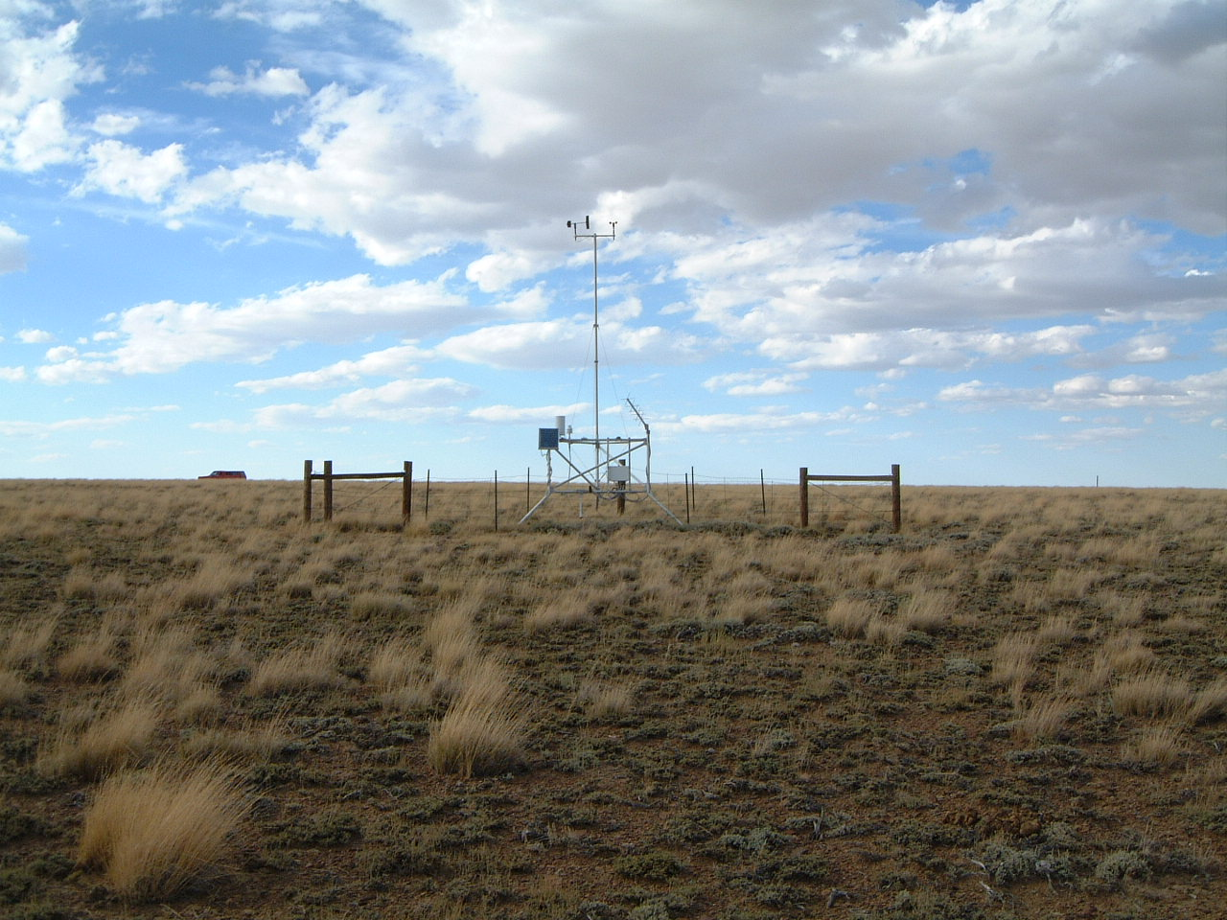
RAWS STATIONS REPORTS (2012 numbers provided for comparison)
Total Precipitation in Inches | April | May | June | July | August | September | October
Snow Spring Creek (Sweetwater County) 481904 | .65 (.27) | 1.41 (.50) | .02  (.01) | .51  (.91) | .75  (.33) | 2.5  (.08) | 1.08  (.59)
Dodge Creek (Albany County) 482106 | .17  (.92) | .62  (.54) | .11  (.01) | 2.72  (.7) | 1.37  (.56) | 2.58  (1.21) | .61  (.37)
Muddy Creek (Uinta County) 481801 | .56  (.33) | .34  (.24) | 0.0  (0.0) | 1.71  (.34) | 1.07  (.03) | 3.56  (.65) | .88  (.83)
Anderson Ridge (Sublette County) 481903 | .13  (.24) | .76  (.57) | .08  (.01) | .74  (.25) | .79  (.45) | 1.58  (.63) | .60  (1.1)
Cow Creek (Carbon County) 482011 | .43  (.27) | 1.14  (.51) | 0.0  (.02) | .91  (.89) | .41  (.58) | 2.03  (.55) | 1.7  (.15)

Average Monthly High Temperatures (Degrees Fahrenheit) | April | May | June | July | August | September | October
Snow Spring Creek (Sweetwater County) 481904 | 54  (51.2) | 65  (59.6) | 77.5  (74.1) | 75.5  (78) | 74.5  (78.8) | 74  (68) | 55.5  (51.2)
Dodge Creek (Albany County) 482106 | 53  (53.1) | 64  (59.5) | 73  (76) | 77.5  (80.3) | 74  (78.4) | 73  (67.9) | 57.5  (48.4)
Muddy Creek (Uinta County) 481801 | 55  (56.8) | 66  (64.2) | 76.5  (77.1) | 77.5  (81.7) | 76.5  (81.7) | 74.5  (72.9) | 57  (55.8)
Anderson Ridge (Sublette County) 481903 | 47.5  (48.9) | 60.5  (56.3) | 72.5  (70.8) | 73  (78.8) | 72  (76.1) | 72  (66.1) | 49  (47.2)
Cow Creek (Carbon County) 482011 | 53.5  (54) | 66  (63.1) | 78  (78.3) | 77  (82) | 76  (79.8) | 75.5  (70.1) | 57.5  (52)

